*Statement of Work* WMS Live 2.0

Version A8

2014-03-17

|  |  |  |  |
| --- | --- | --- | --- |
| Accepted By: | |  | |
| Statkraft | | Knowit Digital Communication AB | |
| Signature: |  | Signature: |  |
| Name: |  | Name: | Oskar Wirmark |
| Date: |  | Date: | 2014-03-11 |

# Background

WMS Live is a graphical presentation of the WMS system that contains real-time data of the Wind Power Fleet.

WMS Live purpose is to spread understanding and interest within Statkraft about wind power generation.

Current WMS Live system is used both on Statkraft´s intranet “the Stream” and on standalone screens.

# Objectives

WMS Live 2.0 shall deliver additional modules with more information together with a possibility to drill down to Wind Park level.

WMS Live 2.0s modules shall be reused in the Wind Dashboard Project and support the daily work of the user of the Wind Dashboard e.g. a Wind Asset Manager. As such the WMS Live 2.0 Project needs deliver functionality according to the requirements concerning graphs in the Wind Dashboard Project.

# Solution Description

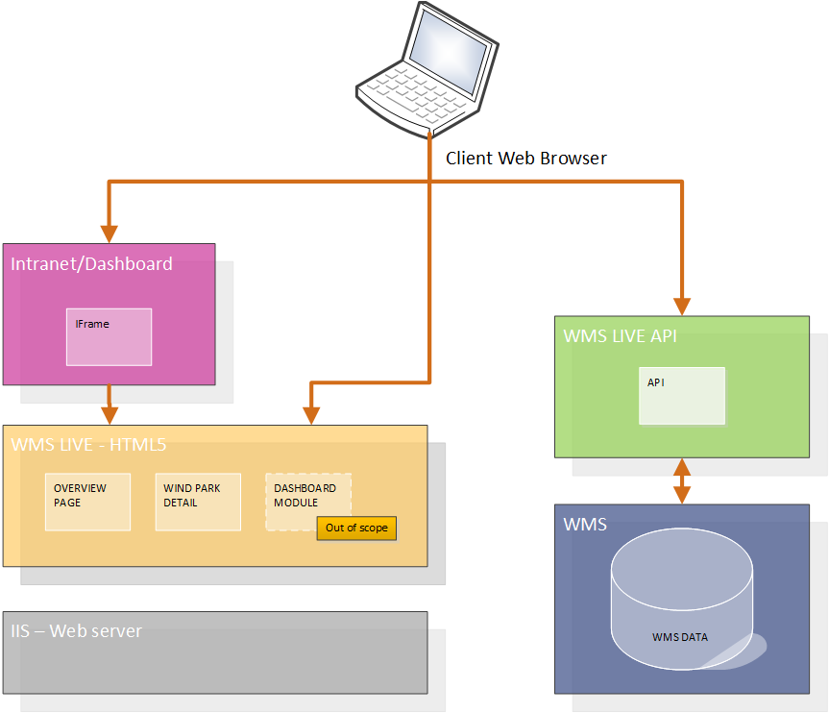

Concept Solution

WMS Live 2.0 will extend the current WMS Live solution with new graphs.

The solution is based on a standalone HTML5/CSS page structure that with help of Java Scripts calls an API deliver by the WMS system. The Java Script enrich the HTML5 page with the data delivered by the API. All logic takes place client side.

# Visual requirements

## Page layout

|  |  |
| --- | --- |
| Start page (Overview) | Wind Park page |

## Screen resolution

## 

## Graphical Components – start page

The following components are part of the Start Page and contains general data.

|  |  |
| --- | --- |
| GC1 - Map | GC2 - Online |
| GC3 - Park Summary | GC3 - Park Summary (Offline mode) |

|  |  |
| --- | --- |
| GC4 - Production | GC5 - Power |
| GC6 - Worth | GC7 - Household |
| GC8 - Comparison | GC9 - Down |

## Graphical Components – Wind Park

The wind park specific page contains “GC1 – Map” & “GC2 – Online” as well as the following components for wind park specific info.

|  |  |
| --- | --- |
| GC10 - Image | GC11 - Layout |
| GC12 - Live Data | GC12 – Live Data (Offline mode) |
| GC13 - Procudtion/Price/Ws | GC14 - Top |

## Changes to current design

* Availability of GC3 should be moved one notch up, price moved to the bottom
* Utilize a decimal for all values of GC3, CG6 and GC12
* Replace the text "Current production ....." to "Supply" in GC7. The details are given in More information
* Use the wrench icon on GC9
* Replacing text in the header on GC9 to: "Turbines with no production for more than two days"
* Removing the park name (ex Smøla) in the header of GC10 and GC12.
* Use yellow or gray bars on the Downtime GC14.
* Replacing text in the header on GC14. "Down Time" to "Turbines with highest downtime the last 10 days”

# Scope

## creative Scope

Explains the creative scope and what limitation applies.

|  |  |
| --- | --- |
| In Scope | Out of Scope |
| * Choice between the two proposed color schemes * Current version of design specification as displayed under Visual requirements * One review round in the end of the development cycle that can accommodate minor visual change * Reordering of the individual order of graphical components on Start page and Wind Park page | * Additional design reviews * Any other changes to the creative scope not specifically defined as in scope |

## Business Process Scope

Explains which business processes are included in the project and which are out of scope

|  |  |
| --- | --- |
| In Scope | Out of Scope |
| * No changes in scope | * Any other changes to business processes not specifically defined as in scope |

## Organization Scope

Explains which organization changes that are supported and which are out of scope.

|  |  |
| --- | --- |
| In Scope | Out of Scope |
| * No changes in scope | * Any other organizational changes not specifically defined as in scope |

## Location Scope

Explains which locations are supported, i.e. where the project should be performed according to agreements between the client and Knowit Digital Communication AB.

|  |  |
| --- | --- |
| In Scope | Out of Scope |
| * Work will be performed from Knowit´s Gothenburg office. * Travels to Statkraft´s Office in Lilleaker will be bill according to established pricelist. | * Any other location not specifically defined as in scope |

## Application Scope

## The application scope defines what tasks the application will perform, and where it will interact with other systems. The system boundaries are presented. Functions, interfaces, documents and wireframes should be listed.

|  |  |
| --- | --- |
| In Scope | Out of Scope |
| **Start page (Overview)**   * Grid set for 480 px width * 9 Graphical components   + GC1 - Map   + GC2 - Online   + GC3 - Park Summary   + GC4 - Production   + GC5 - Power   + GC6 - Worth   + GC7 - Household   + GC8 - Comparison   + GC9 - Down | **Start page (Overview)**   * Responsive design * Any other functionality not specifically defined as in scope |
| **Wind Park page**   * Grid set for 480 px width * Mechanism for choosing wind park based on url get parameter “windparkid” * 7 Graphical components   + GC1 – Map   + GC2 - Online   + GC10 - Image   + GC11 - Layout   + GC12 - Live Data   + GC13 - Production/Price/Ws   + GC14 - Top | **Wind Park page**   * Responsive design * Any other functionality not specifically defined as in scope |
|  | * Current TV screen page * Additional Pages |
| **GC1 – Map**   * Grid set for 480 px width * Back to “Start page” button appears when this component is used in a ”Wind Park page” * Auto focus on specific wind park when used on a ”Wind Park page” * Google Maps frame   + Existing Visual styling   + Wind park needles are links to “Wind park page” * Tab for toggle to GC2 | **GC1 – Map**   * Responsive design * Any other functionality not specifically defined as in scope |
| **GC2 - Online**   * Grid set for 480 px width * Status displayed by color of bullet * Tab for toggle to GC1 | **GC2 - Online**   * Responsive design * Client side sorting of wind parks, API should deliver in wanted order e.g. alphabetic * Any other functionality not specifically defined as in scope |
| **GC3 - Park Summary**   * Grid set for 480 px width * Automatic switch of the 3 current visual wind parks * On mouse hover arrow buttons that steps forward and backward in the loop * Offline mode shows “no data available” when API reports wind park as offline | **GC3 - Park Summary**   * Responsive design * Client side sorting of wind parks, API should deliver in wanted order * Any other functionality not specifically defined as in scope |
| **GC4 - Production**   * Grid set for 480 px width * Shows production last 10 days * Auto scale according to maximum value * Shows total production numbers for all wind parks | **GC4 - Production**   * Responsive design * Any other data focus e.g. specific wind park * Any other functionality not specifically defined as in scope |
| **GC5 - Power**   * Grid set for 480 px width * Shows power production in % for all wind parks | **GC5 - Power**   * Responsive design * Any other data focus e.g. specific wind park * Any other functionality not specifically defined as in scope |
| **GC6 - Worth**   * Grid set for 480 px width * Shows 4 market prices   + Norway   + Sweden   + UK onshore   + UK offshore | **GC6 - Worth**   * Responsive design * Any other data focus e.g. specific wind park * Any other functionality not specifically defined as in scope |
| **GC7 - Household**   * Grid set for 480 px width * Shows current production for 3 markets   + Norway   + Sweden   + UK | **GC7 - Household**   * Responsive design * Any other data focus e.g. specific wind park * Any other functionality not specifically defined as in scope |
| **GC8 - Comparison**   * Grid set for 480 px width * Shows 4 values   + Today   + Yesterday   + Euros   + % | **GC8 - Comparison**   * Responsive design * Any other data focus e.g. specific wind park * Any other functionality not specifically defined as in scope |
| **GC9 - Down**   * Grid set for 480 px width * Solution will truncate the list of turbines with “…” after a line is full | **GC9 - Down**   * Responsive design * Client side sorting of wind parks, API should deliver in wanted order e.g. the wind park with the most turbines down first * Any other functionality not specifically defined as in scope |
| **GC10 - Image**   * Grid set for 480 px width * Displays following fields   + Name   + Country   + Location   + Turbines   + Installed Power   + Site Manager * Tab for toggle to GC11 | **GC10 - Image**   * Responsive design * Background Images * Any other functionality not specifically defined as in scope |
| **GC11 - Layout**   * Grid set for 480 px width * Tab for toggle to GC10 | **GC11 - Layout**   * Responsive design * Layout Images * Any other functionality not specifically defined as in scope |
| **GC12 - Live Data**   * Grid set for 480 px width * Displays following fields   + Wind speed   + Power   + Availability   + Price   + Wind direction, 8 possible wind directions * Offline mode shows “no data available” when API reports wind park as offline | **GC12 - Live Data**   * Responsive design * Any other functionality not specifically defined as in scope |
| **GC13 - Production/Price/Ws**   * Grid set for 480 px width * Two modes   + Production/Price   + Production/ws * Tab for toggle between modes * Production displayed as Bar charts * Price and Wind Speed displayed as Line chart | **GC13 - Production/Price/Ws**   * Responsive design * Any other functionality not specifically defined as in scope |
| **GC14 – Top**   * Grid set for 480 px width * Two half width panes   + Top turbines (5 bars)   + Downtime turbines (5 bars) | **GC14 - Top**   * Responsive design * Client side sorting of turbines, API should deliver in wanted order * Any other functionality not specifically defined as in scope |

## Data Scope

## Explains which data should be considered in the project and which data are out of scope.

|  |  |
| --- | --- |
| In Scope | Out of Scope |
| * WMS Live API specification needed to support the solution. (Requirement to Statkraft) | * Implementation of WMS Live API. |

# Approach

Knowit Digital Communication works according to a wheel process. This SOW primarily covers the third step “Development” as the Strategy and Communication steps already been covered resulting in the visual requirement.

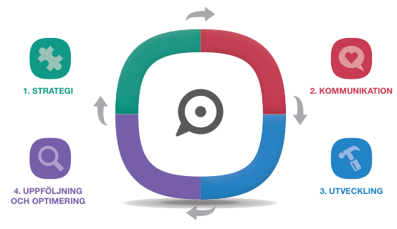

## Project plan

Project model is chosen based on the project’s needs, in this case waterfall is the best match.

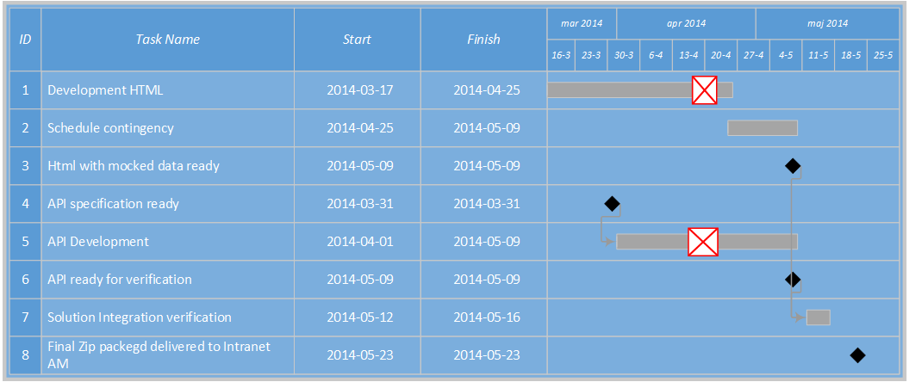

# Deliverables

|  |  |  |
| --- | --- | --- |
| ID | Deliverables | Description |
| 1 | Design  Ready | Photoshop files of final design |
| 2 | WMS Live API requirement  2014-03-24 | Requirements specifying changes needed to the WMS Live API |
| 3 | HTML Package  2014-05-01 | Zip archive containing HTML5 standalone pages with needed CSS files and (if needed) images. Ready for Intranet AM team to deploy |

# Assumptions

* All data for visualization will be delivered by the WMS Live API, only exception is images which should be delivered in a structured way
* Statkraft has verified that all data aspects of the Visual requirements defined by the designed pages is available in WMS and feasible to add to the current WMS Live API.
* Statkraft caters for the coordination and implementation of the API changes.
* Modularity is deliver by the fact that the different graphical modules of the HMTL5 pages can easily be “cut and pasted” in to new pages by a front end developer with small development efforts. But it will require development work.
* A wind park has some key or identifier that can be used in API data and page views, we have referred to it as “windparkid” in this SOW
* Layouts to be used in “GC11 – Layouts” will be delivered by Statkraft or ordered separately
* Images to be used in “GC10 – Image” will be delivered by Statkraft or ordered separately, images should be in a structured way e.g. named after “windparkid”

# Statkraft´s Responsibilities

|  |  |  |
| --- | --- | --- |
| ID | Due Date | Definition |
| 1 | 2014-03-17 | Sign off on start, design specification (DG3) |
| 2 | 2014-04-01 | Layouts to be used in “GC11 – Layouts” |
| 3 | 2014-04-01 | Images to be used in “GC10 – Image” |
| 4 | 2014-04-07 | Chose color scheme |
| 5 | 2014-04-07 | Participate in review/demo for final feedback |
| 6 | 2014-04-07 | Deadline for deciding order of graphical components |
| 7 | 2014-04-17 | Deliver the new version of WMS Live API according to Knowit´s specifications deployed to preprod |